CL2005

Database Systems Lab
Animal Hospital and Shelter Management System

3. Paw Track

Semester Fall 2025

Submitted to: Mr Ahsan Shakeel

Submitted by:
CY-A
Eman Akbar
22i-1588
Sarita Sangrez
23i-2088
Amna Ali
23i-2067
Submission Date: 9/12/25
Deadline: 10/12/25

Contents
Section:1 Summary of Changes 2
Section:2 System Overview 3
2.1 Animal Module 3
2.2 Adopter Module 4
2.3 Adoption Module 4
2.4 Appointment Module 4
2.5 Treatment Module 5
2.6 Staff Module 5
2.7 Visual and Navigation Structure 6
Section: 3 Application Screenshots 7
A. Animals 7
B. Adopters 11
C. Adoptions 17
D. Appointments 22
E. Treatments 28
F. Staff 34
Section:4 Challenges & Future Enhancements 40

Section:1 Summary of Changes
Deliverable 3 expands the PawTrack Veterinary Information Tracking (VIT) System beyond the earlier Deliverable 2 prototype, which mainly allowed simple data insertion into the database. In this phase, the system begins to resemble a more practical animal hospital and shelter management platform, because it now supports full CRUD (Create, Read, Update, Delete) functionality for the core operational entities. These entities, such as Animals, Adopters, Appointments, Treatments, Adoptions, and Staff represent the everyday workflow items that must be tracked in a real shelter or small veterinary clinic.
The purpose of this deliverable is not only to list, edit, and delete stored information, but also to introduce a more structured and usable interface. Although the application is still lightweight, these additions make the system feel more “complete,” as users can now perform actual management tasks instead of only inserting records. To avoid breaking any previously working features, all D3 additions are carefully layered on top of the existing D2 insertion logic, with no alterations to the earlier database interactions.
The technology stack continues unchanged from Deliverable 2:
- Node.js with Express provides server-side logic and routing,
- EJS templates handle the dynamic rendering of views, and
- MySQL remains the central storage location for all entity records.
Deliverable 3 also introduces meaningful improvements in usability and appearance. While still modest, the updated visual design attempts to resemble a functional internal tool used inside an animal shelter or veterinary office, where staff require clear tables, readable forms, and simple navigation. Basic business rules, non-editable IDs, foreign key restrictions, and validation checks further push the system toward realistic operational behaviour.

Section:2 System Overview
In Deliverable 2, the PawTrack system mainly offered basic input screens for inserting new data into the database. Each module, including Animal, Adopter, Adoption, Appointment, Treatment, and Staff, provided only a single form that allowed users to add records. Although the forms successfully stored data in MySQL, users had no way to view, modify, or remove existing information. This limited the system’s usefulness as a real animal hospital and shelter management tool.
Deliverable 3 expands these modules so that each now supports the full set of core use cases. The system includes dedicated pages for listing records, editing entries, and deleting outdated information. This allows shelter staff to interact with data in a way that matches real operational workflows.

2.1 Animal Module
The Animal module now consists of several pages that support the complete lifecycle of animal information:
- A form page for adding new animals.
- A list page for viewing all animals currently stored in the shelter database.
- An edit page that loads an existing animal record so the user can update details such as name, species, breed, status, and room assignment.
- A delete action that allows removal of an animal record after confirmation.
This module now supports use cases such as registering new intakes, updating an animal’s status during treatment, and maintaining accurate shelter occupancy records.

2.2 Adopter Module
The Adopter module now contains:
- A form page for registering a new adopter with validated fields such as name, phone, email, and CNIC.
- A list page for reviewing all adopters currently in the system.
- An edit page that allows updates to an adopter’s contact information.
- A delete action for removing adopters who are no longer active.
This supports use cases such as keeping adopter profiles up to date and reviewing adopter information before processing an adoption.

2.3 Adoption Module
The Adoption module handles the adoption workflow and includes:
- A form page for recording a new adoption.
- A list page that displays all adoption transactions including animal and adopter details.
- An edit page that allows changes to the adoption date or associated file, while keeping the linked AnimalID and AdopterID fixed.
- A delete action for removing adoption records when appropriate.
This matches use cases such as verifying adoption history, correcting recorded dates, and maintaining official adoption documentation.

2.4 Appointment Module
Deliverable 3 adds the following appointment-related pages:
- A form page for scheduling a new appointment between an animal and a veterinarian.
- A list page that shows all upcoming and completed appointments.
- An edit page that allows changes to the date, time, or status of an appointment, while keeping AnimalID and VetID fixed.
- A delete action for removing appointments that are no longer valid.
This supports veterinary workflows such as scheduling, rescheduling, tracking appointment outcomes, and managing clinical activity.

2.5 Treatment Module
The Treatment module now includes:
- A form page for recording a treatment event.
- A list page that displays all treatment entries along with diagnosis and prescription information.
- An edit page for updating diagnosis and prescription details, with AnimalID and VetID kept read-only.
- A delete action for removing treatment records.
These pages support use cases such as documenting medical care, updating treatment notes, and reviewing an animal’s clinical history.

2.6 Staff Module
The Staff module has been expanded to include:
- A form page for adding new staff members, including admins, veterinarians, and volunteers with role-specific fields.
- A list page that displays all staff members and their roles.
- An edit page that allows modification of basic staff information while keeping StaffID, Role, and Username fixed.
- A delete action for removing staff records after verification.
This matches use cases such as maintaining staff directories, updating contact details, and managing personnel records.

2.7 Visual and Navigation Structure
To support all modules more clearly, each page was redesigned in Deliverable 3 using a shared layout. All form, list, and edit pages now:
- use a centered wrapper and card layout for readability
- include a Home button for consistent navigation
- follow the same styling defined in public/css/styles.css
- present lists in an organized table format
- provide clear success and error pages with links to relevant actions
The home page has been reorganized into two clear groups of tasks:
- Data insertion pages from Deliverable 2
- Data management pages from Deliverable 3
This structure helps users understand where to add information and where to manage existing records.

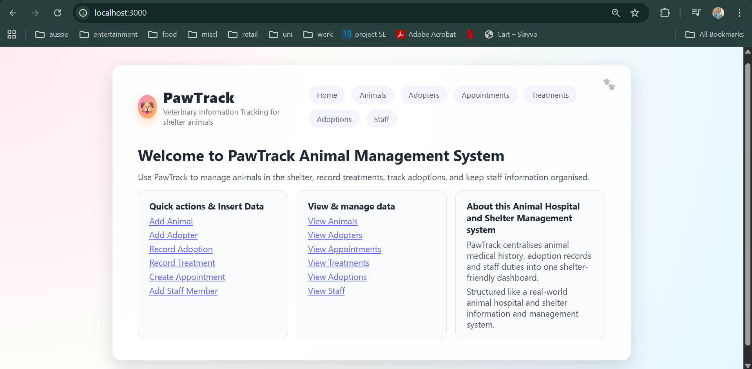

Section: 3 Application Screenshots
All Use Cases Tested, depicting workflow as well

A. Animals
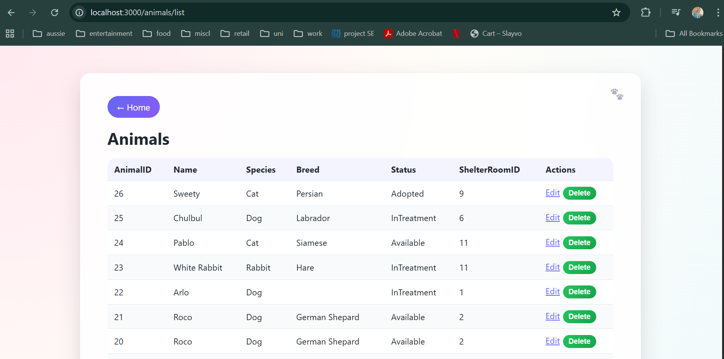

A1 – Insert New Animal
- Precondition: Application running, DB connected.
- Steps:
  - Click “Add Animal”.
  - Fill in Name, Species, Breed, Gender, Date of Birth, Status, Shelter Room.
  - Click Save.
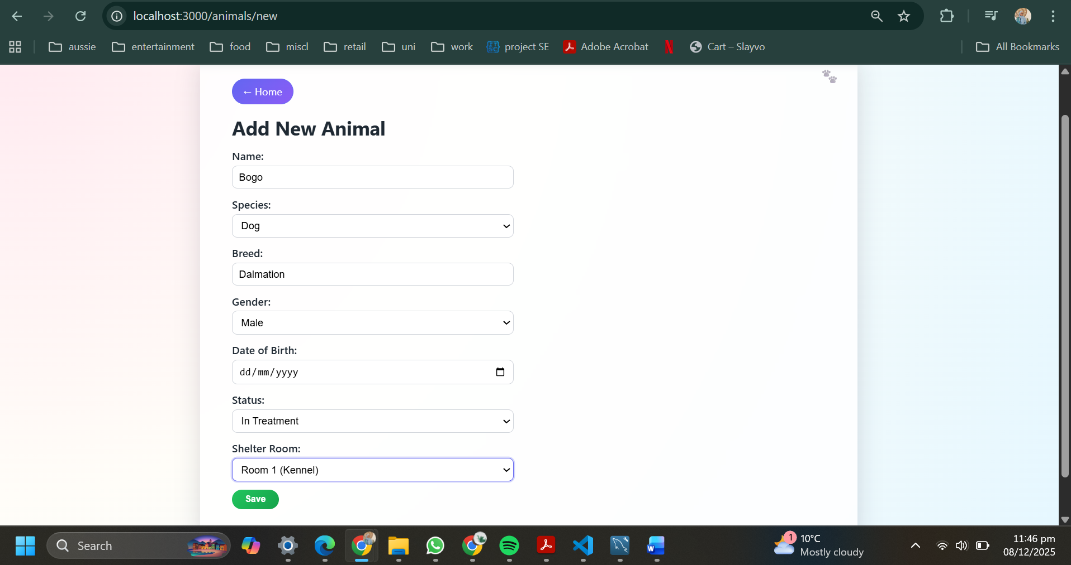
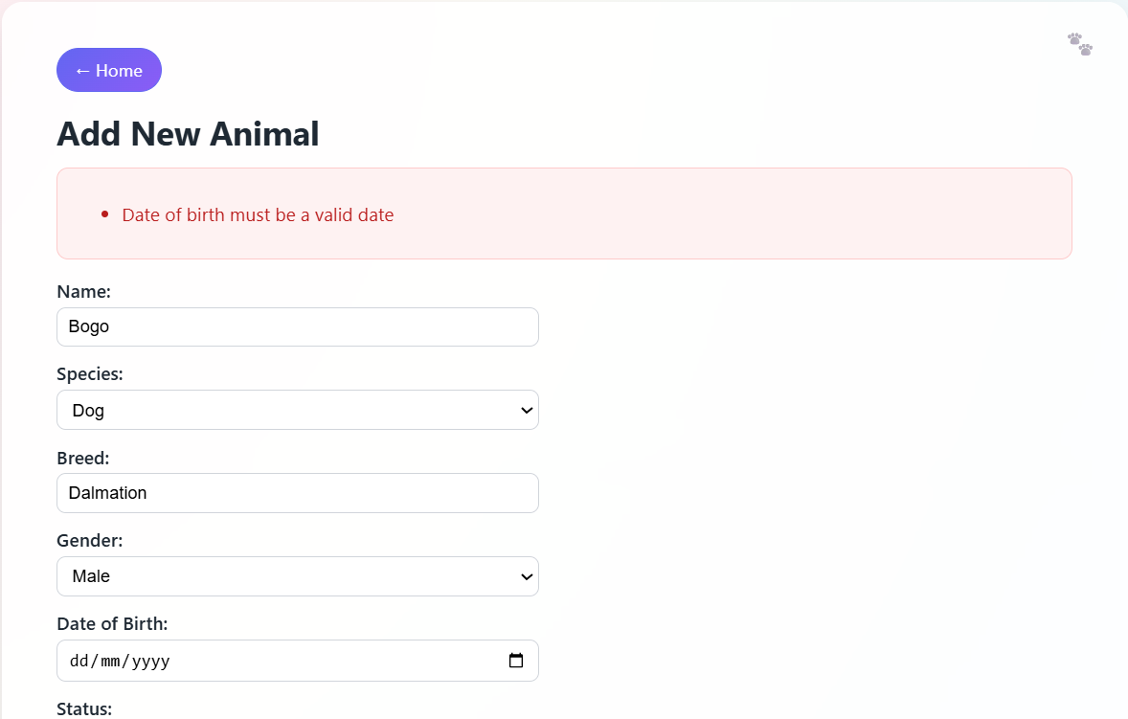
(Validation check)
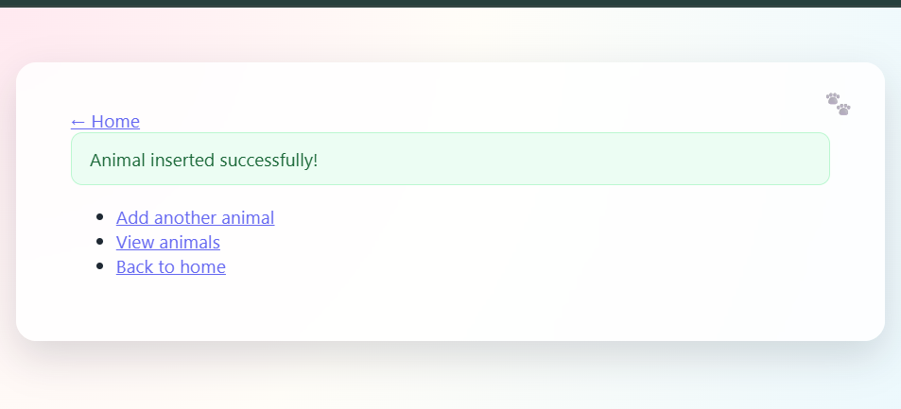
- Expected:
  - Success page appears.
  - On “View Animals” (/animals/list), the new animal appears in the table.

A2 – Edit Animal (Status Change)
- Steps:
  - Go to /animals/list.
  - Click Edit on an existing animal.
  - Click Save Changes.
- Expected:
  - Redirect back to /animals/list.
  - Updated status visible in the table.
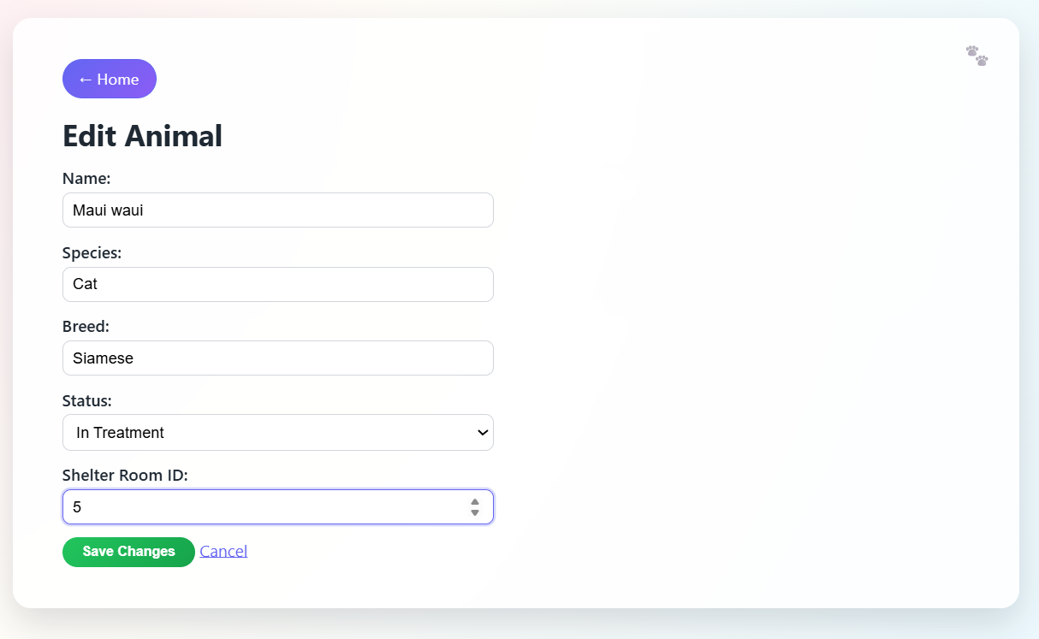
Changed shelter room number
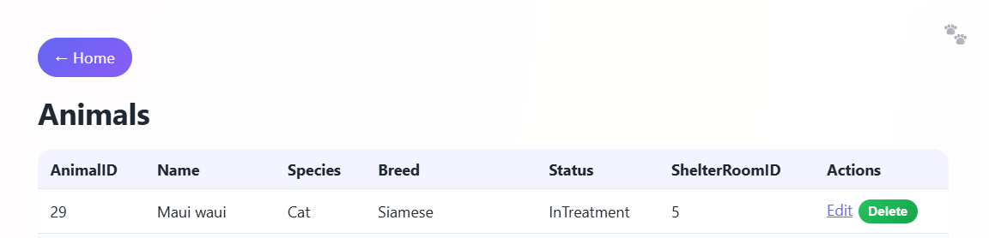
Updated
A3 – Delete Animal
- Steps:
  - Go to /animals/list.
  - Click Delete on an animal row.
  - Confirm the JavaScript prompt.
- Expected:
  - Animal disappears from the list (unless blocked by foreign key constraints such as existing adoptions or treatments; in that case, an error is shown).
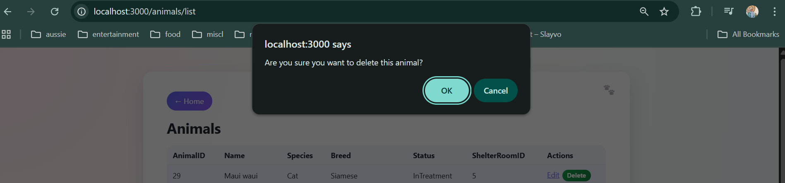

Maui Waui successfully deleted

B. Adopters
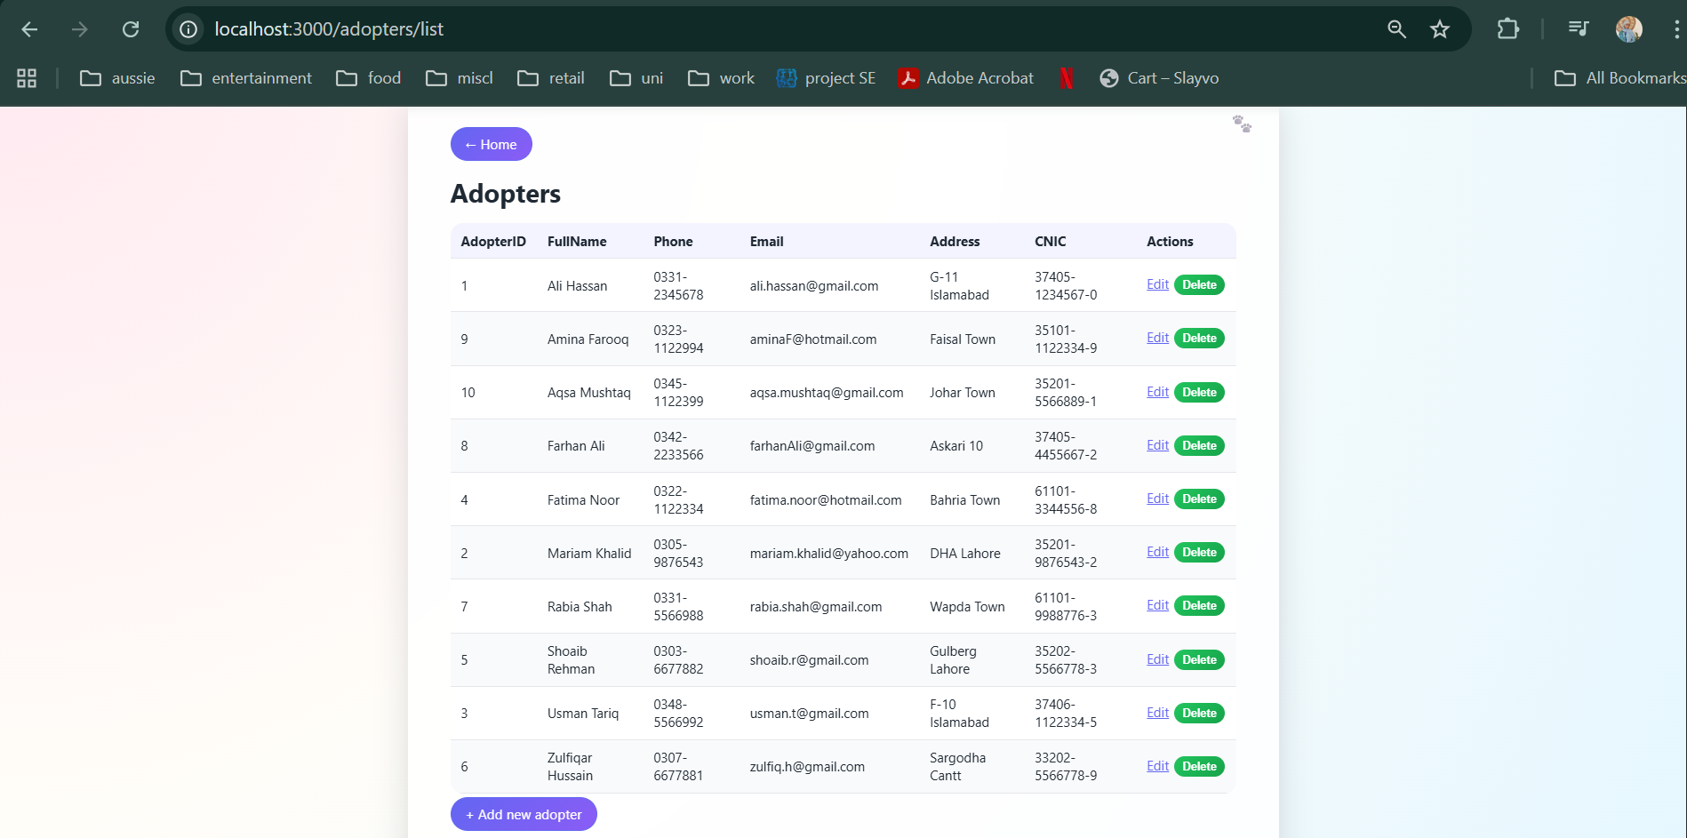
B1 – Register New Adopter
- Steps:
  - From home, click “Add Adopter”.
  - Enter Full Name, Phone, Email, Address, CNIC with the correct 12345-1234567-1 format.
  - Submit.
- Expected:
  - Success message.
  - /adopters/list contains the new adopter row.
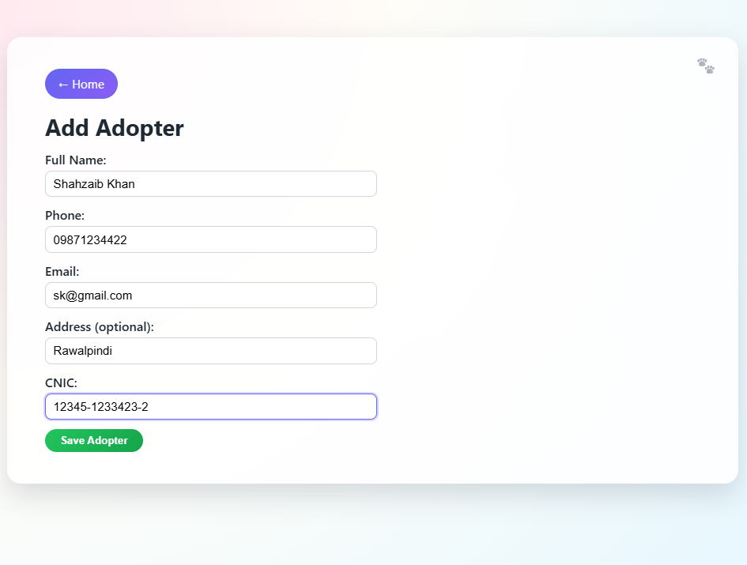
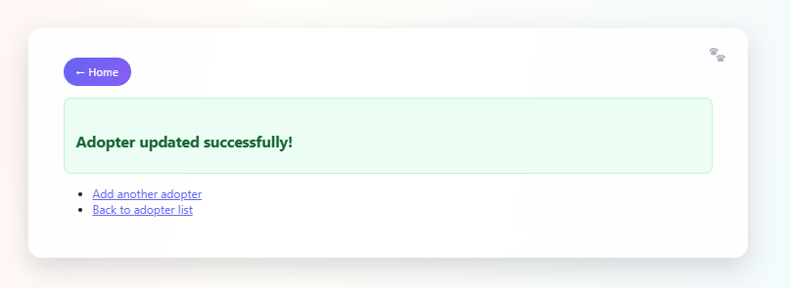

B2 – Validation Error on Adopter
- Steps:
  - Go to /adopters/new.
  - Leave email blank or enter invalid email, e.g. abc@.
  - Click Save Adopter.
- Expected:
  - Page re-renders with red error box listing validation errors.
  - Previously typed fields are preserved.
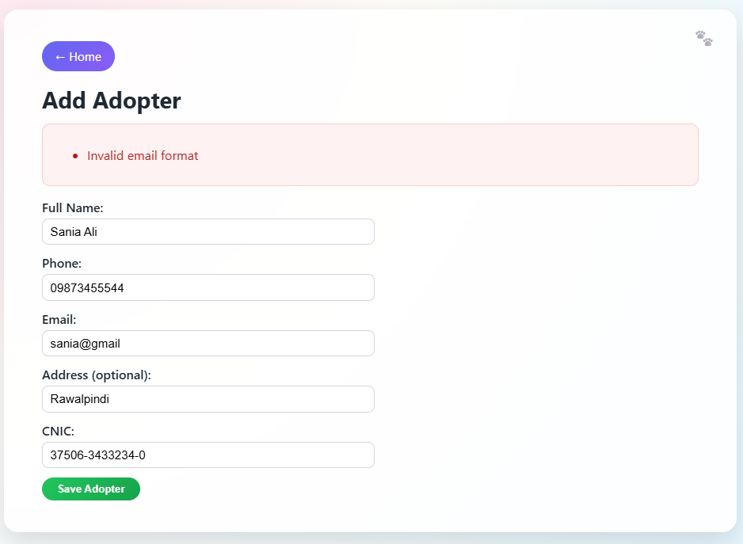
B3 – Edit Adopter
- Steps:
  - Go to /adopters/list.
  - Click Edit on a row.
  - Update phone number or address.
  - Click Save Changes.
- Expected:
  - Changes appear in the list.
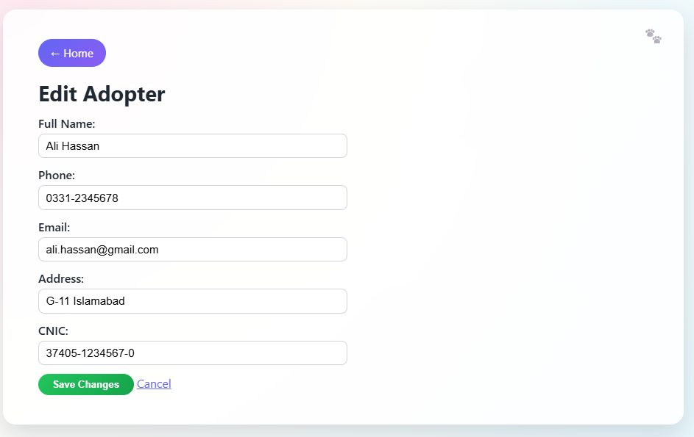
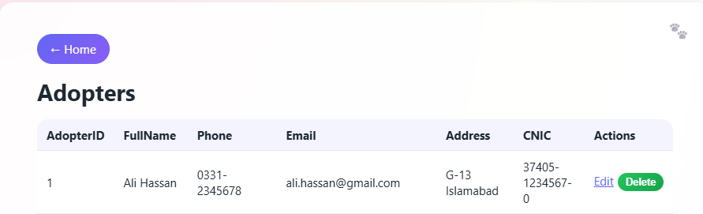
B4 – Delete Adopter
- Steps:
  - Go to /adopters/list.
  - Click Delete for an adopter.
  - Confirm.
- Expected:
  - Adopter is removed from the table (unless referenced by an adoption).
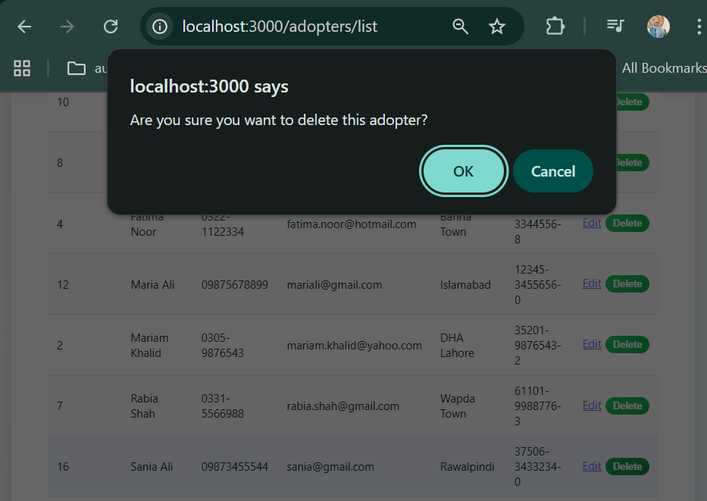
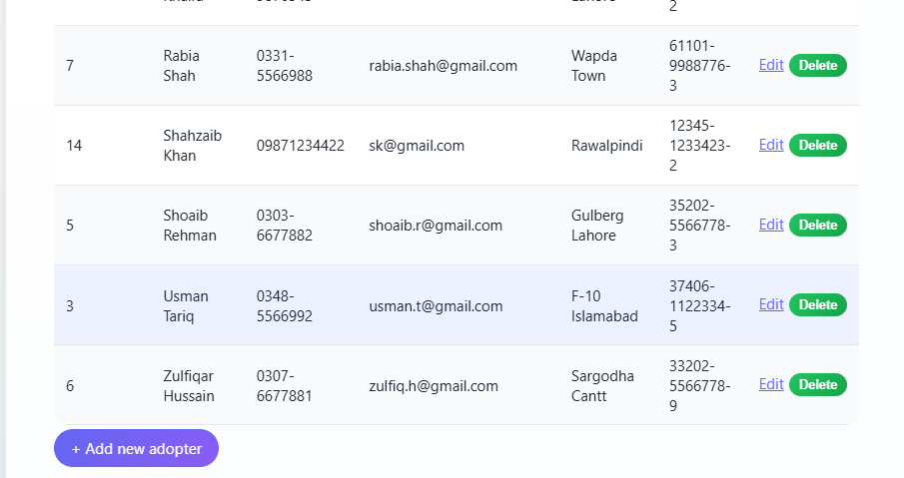
Sania Successfully deleted

C. Adoptions
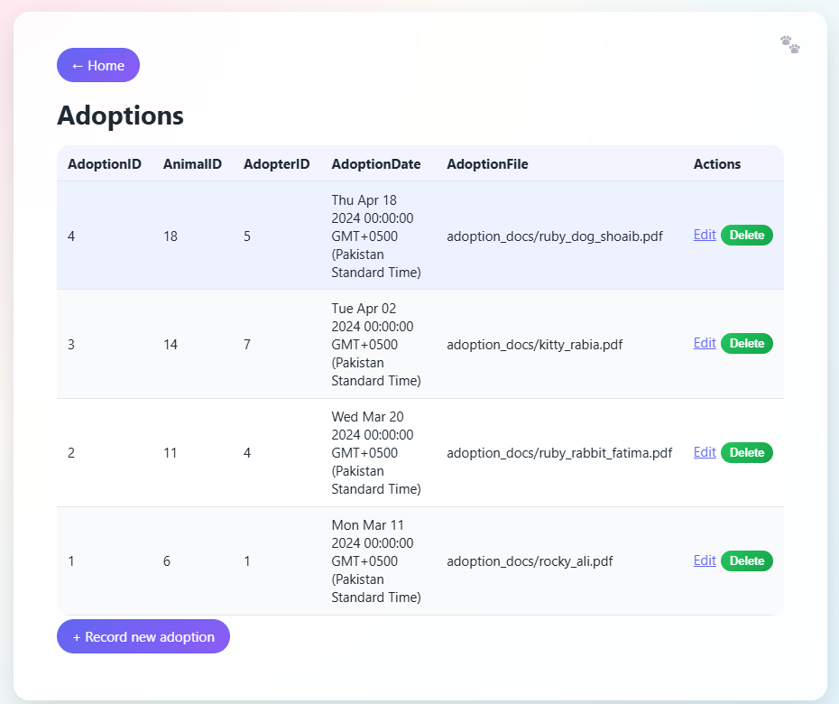
C1 – Record Adoption
- Precondition: At least one “Available” animal and one adopter exist.
- Steps:
  - Go to /adoptions/new.
  - Choose an AnimalID and AdopterID from the dropdowns.
  - Select adoption date and optional file path.
  - Submit the form.
- Expected:
  - Success page.
  - /adoptions/list shows a new record with the chosen IDs.
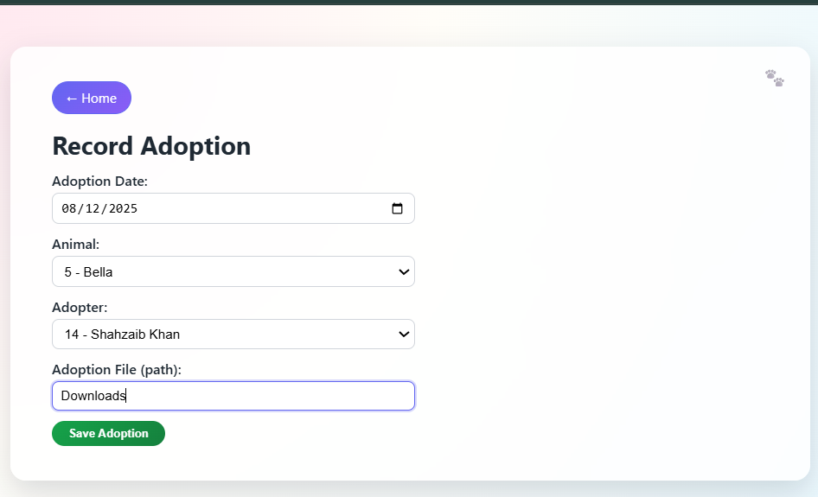
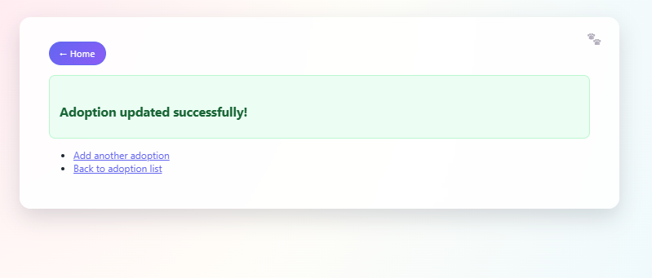
C2 – Edit Adoption (Date / File Only)
- Steps:
  - Go to /adoptions/list.
  - Click Edit.
  - Note that Animal ID and Adopter ID are displayed but not editable.
  - Change adoption date or file.
  - Click Save Changes.
- Expected:
  - Redirect to /adoptions/list.
  - Updated date/file visible.
  - No foreign key errors.
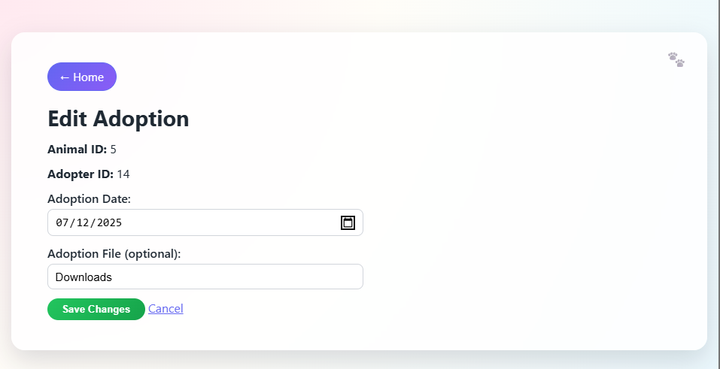
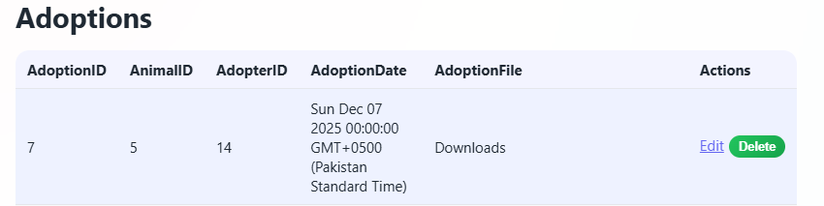
Date changed to 7th Dec
C3 – Delete Adoption
- Steps:
  - Go to /adoptions/list.
  - Click Delete on an adoption.
- Expected:
  - Adoption record disappears from the list.
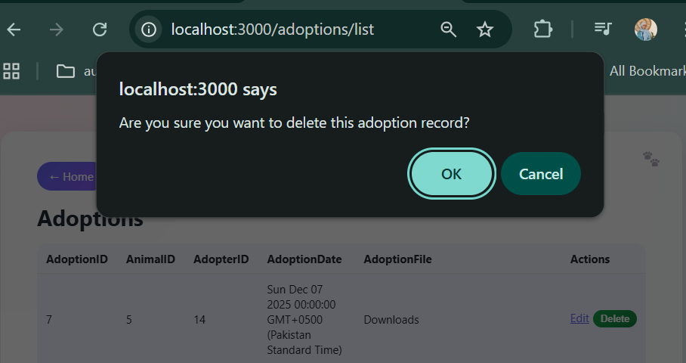
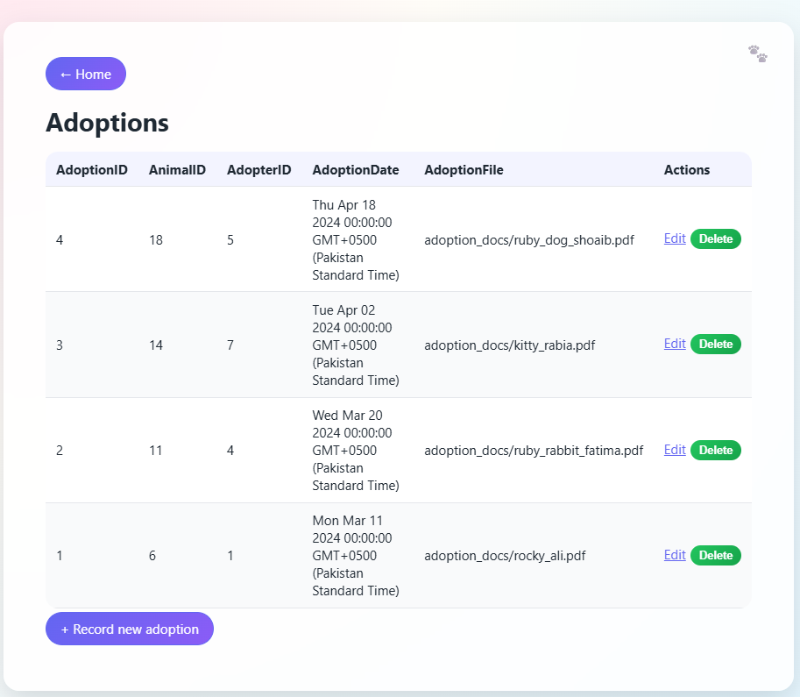
Adoption ID 7 deleted record

D. Appointments
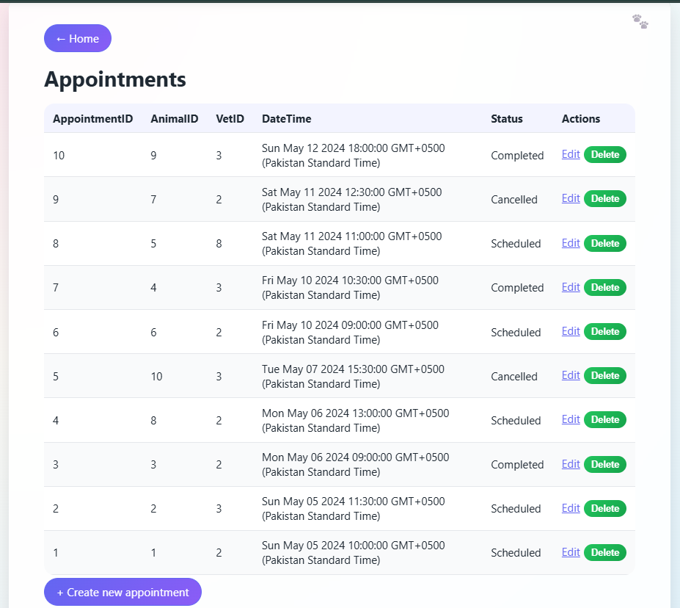
D1 – Create Appointment
- Precondition: At least one animal and one vet exist.
- Steps:
  - Go to /appointments/new.
  - Select an animal and vet from dropdowns.
  - Pick a future date/time.
  - Choose status (or leave default “Scheduled”).
  - Submit.
- Expected:
  - Success page.
  - /appointments/list shows the new appointment.
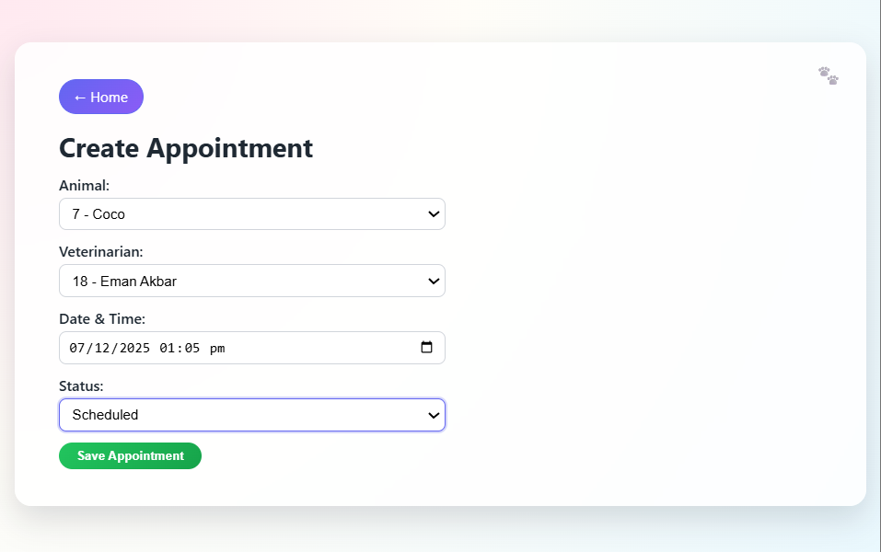
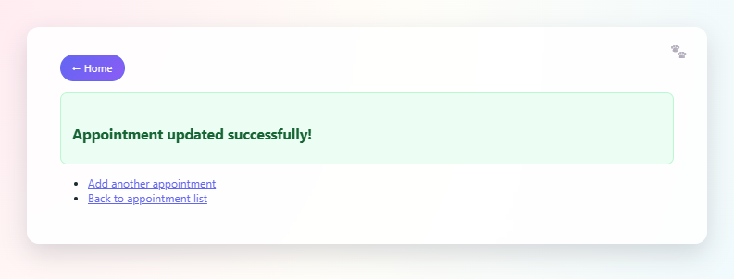
D2 – Edit Appointment (No ID Changes)
- Steps:
  - Go to /appointments/list.
  - Click Edit.
  - Verify that Animal ID and Vet ID inputs are read-only.
  - Change date/time or status (e.g., from Scheduled to Completed).
  - Save.
- Expected:
  - Time/status updated in the table.
  - No error about invalid datetime.
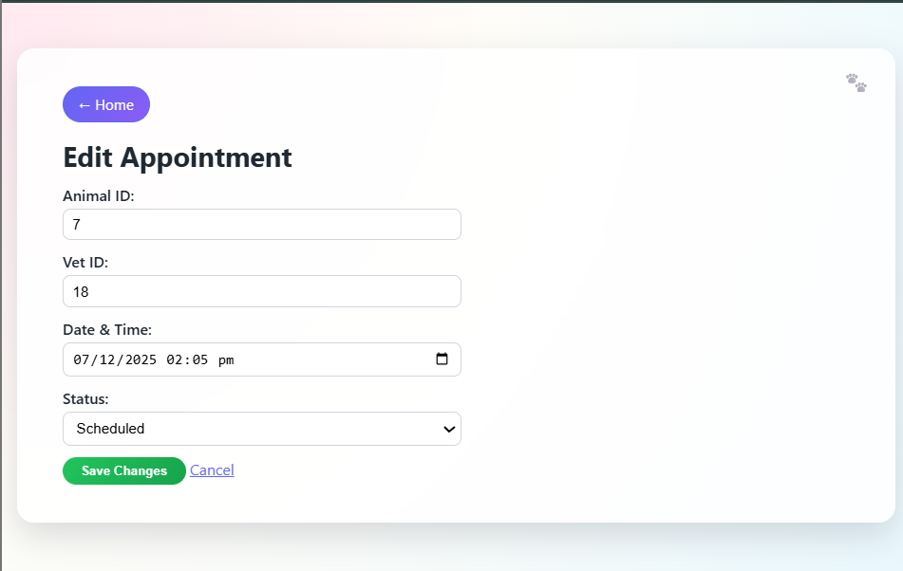
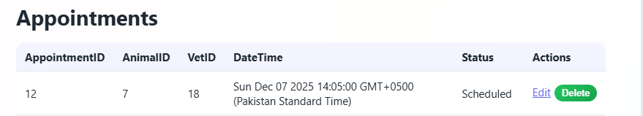
Appointment Time changed an hour later
D3 – Delete Appointment
- Steps:
  - From /appointments/list, click Delete on one row.
  - Confirm.
- Expected:
  - Row removed from the table.
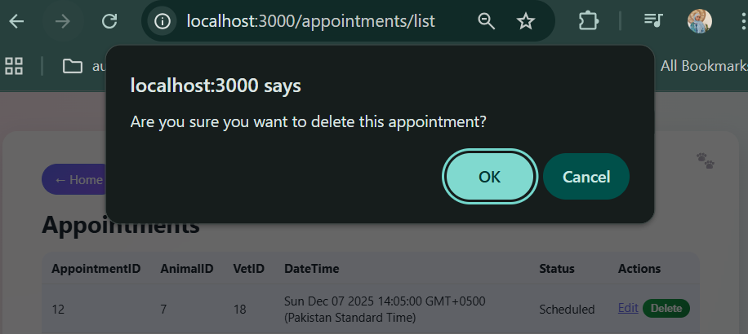
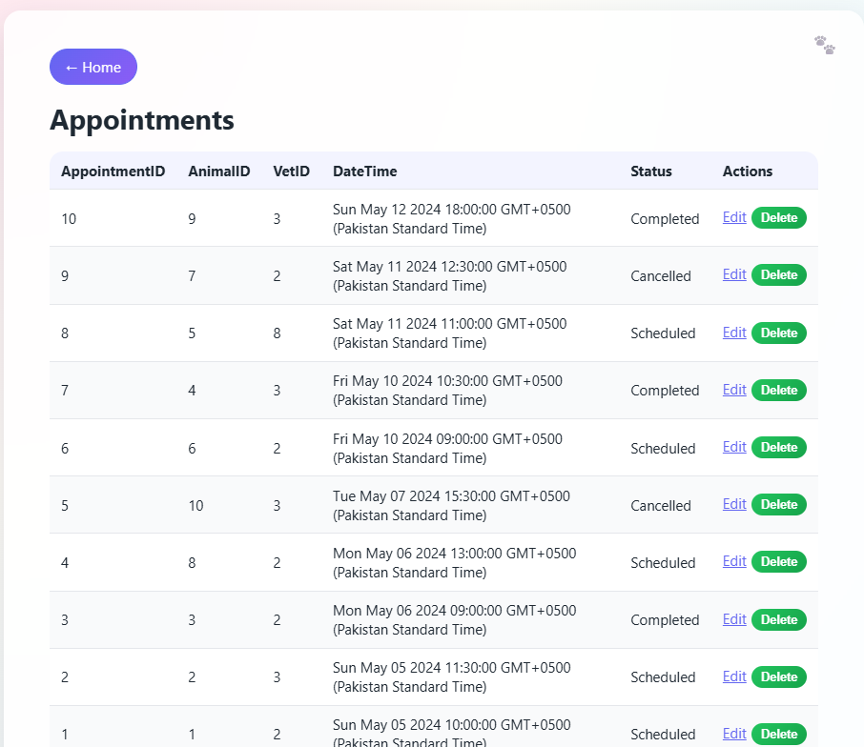
7th ID appointment successfully deleted

E. Treatments
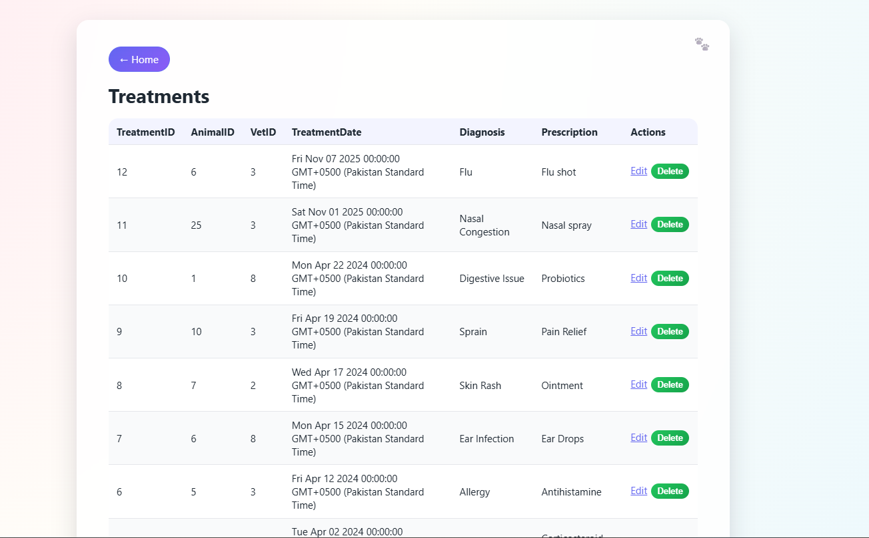
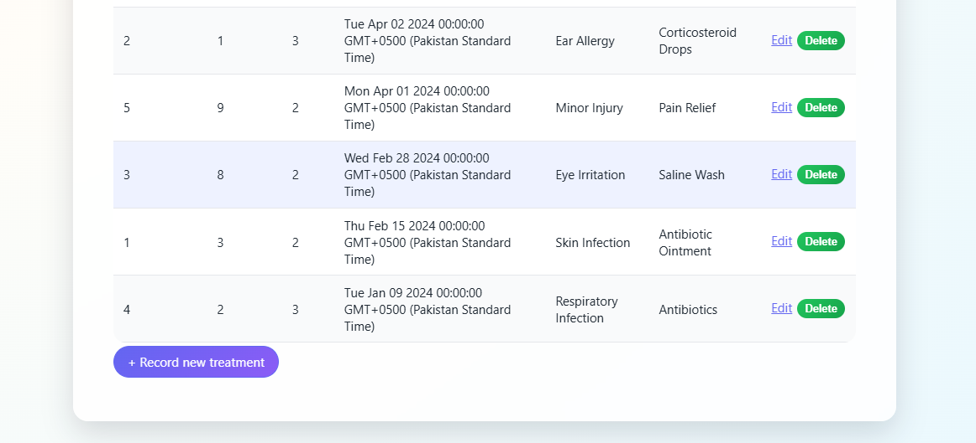
E1 – Record Treatment
- Precondition: At least one animal and one vet exist.
- Steps:
  - Go to /treatments/new.
  - Select animal and vet.
  - Provide treatment date, diagnosis, and (optionally) prescription.
  - Submit.
- Expected:
  - New treatment appears on /treatments/list.
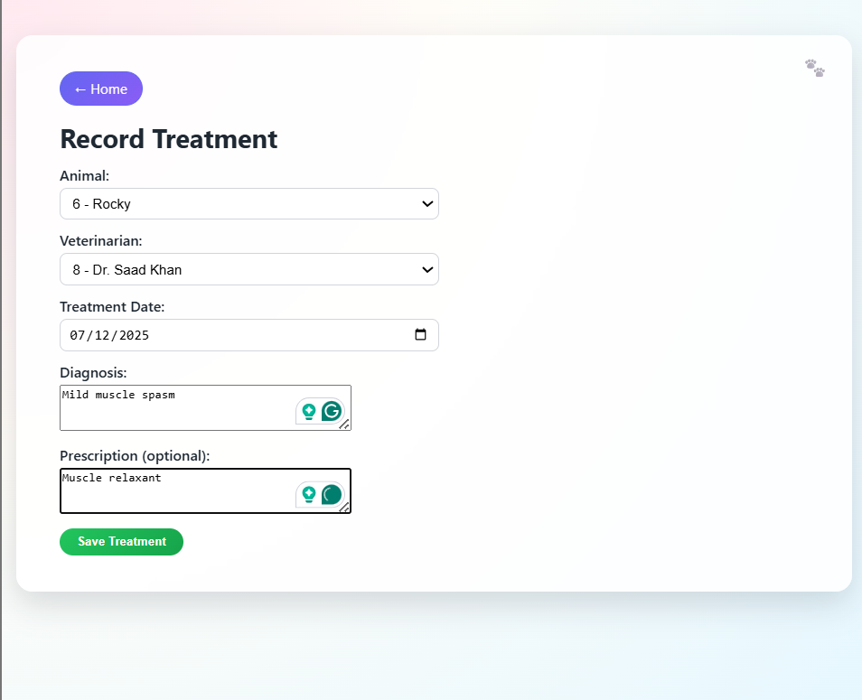
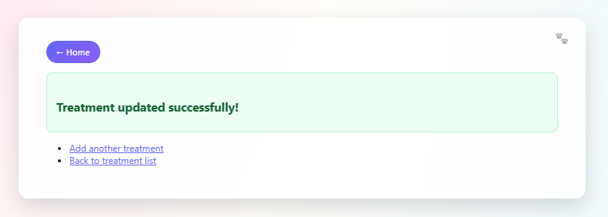
E2 – Edit Treatment (IDs Read-Only)
- Steps:
  - Go to /treatments/list.
  - Click Edit on a record.
  - Confirm Animal ID and Vet ID are read-only.
  - Change diagnosis and/or prescription.
  - Save changes.
- Expected:
  - Updated diagnosis/prescription visible in the list.
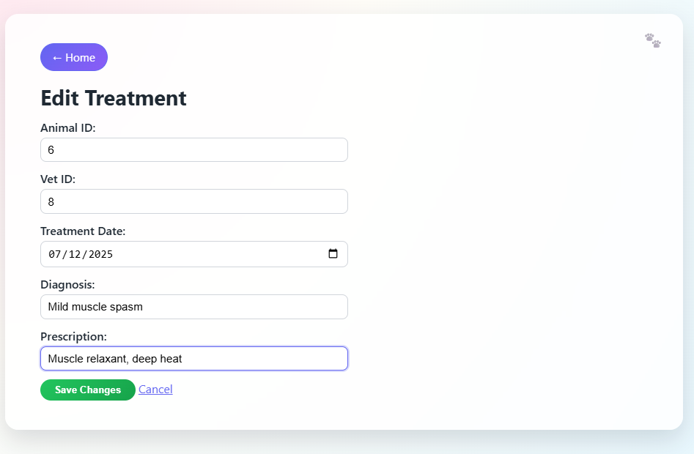
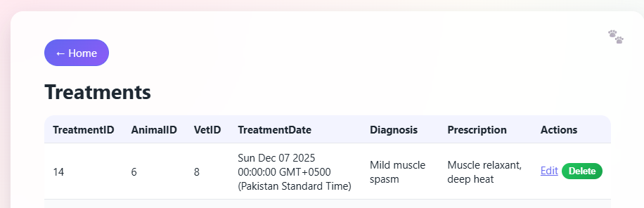
Added a new medicine here
E3 – Delete Treatment
- Steps:
  - From /treatments/list, delete a treatment.
- Expected:
  - Record is removed, unless constrained by other business rules.
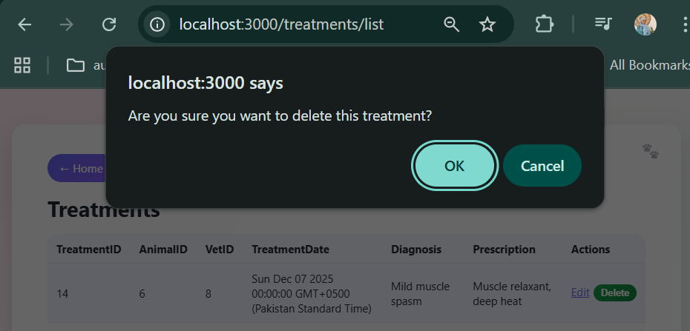
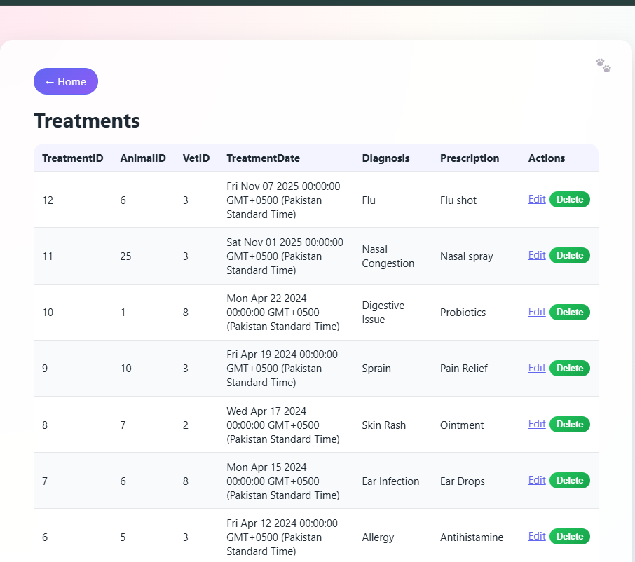
Treatment ID 14 deleted

F. Staff
F1 – Add Staff Member
- Steps:
  - Go to /staff/new.
  - Fill name, phone, email, role, username, password.
  - For Admin/Vet, fill salary (and specialization/license for Vet).
  - For Volunteer, fill availability.
  - Submit.
- Expected:
  - Success message.
  - /staff/list shows new staff entry.
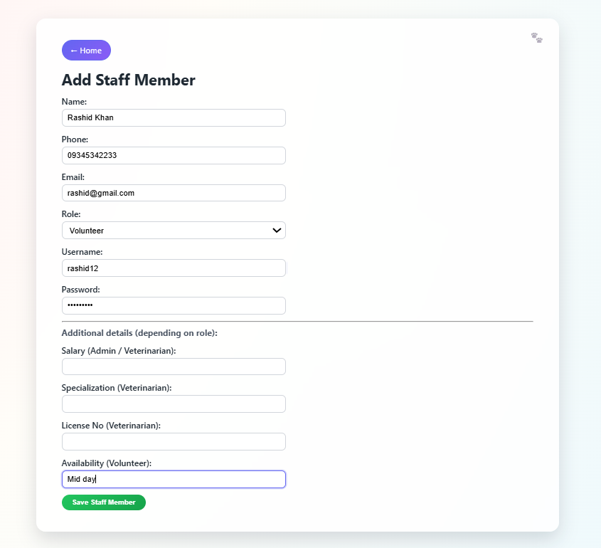
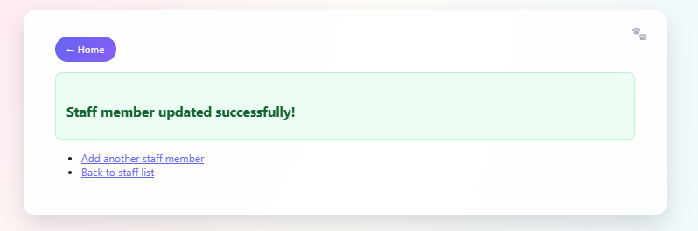
F2 – Validation Error (Role-based Fields)
- Steps:
  - Choose role “Veterinarian” but leave specialization or license blank.
  - Submit.
- Expected:
  - Error box stating that specialization and license number are required.
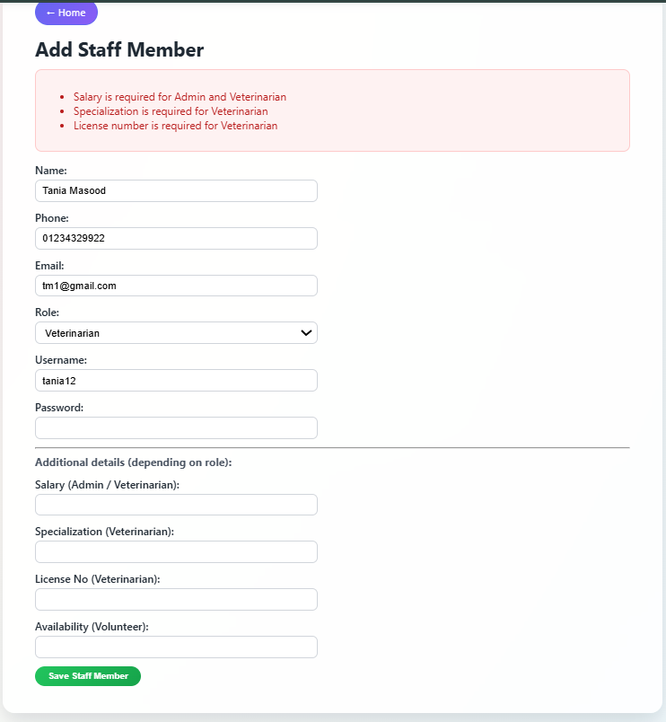
F3 – Edit Staff (Profile Only)
- Steps:
  - Go to /staff/list.
  - Click Edit for a staff member.
  - Note that Staff ID, Role, and Username are read-only labels.
  - Change phone or email.
  - Save.
- Expected:
  - List shows updated contact details.
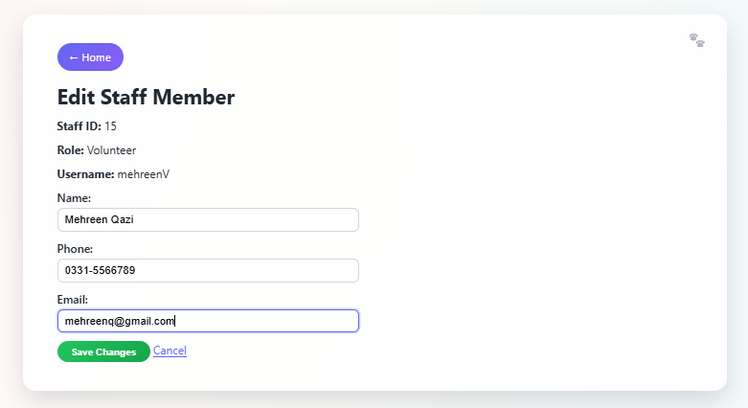
F4 – Delete Staff
- Steps:
  - From /staff/list, delete a staff member.
- Expected:
  - Record removed or an error displayed if referenced by other tables.
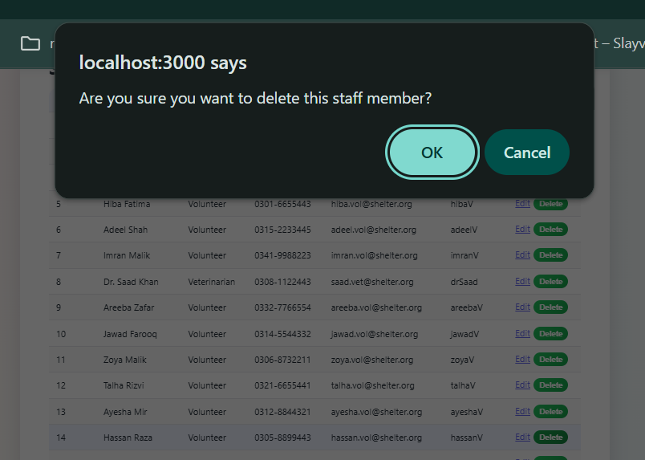
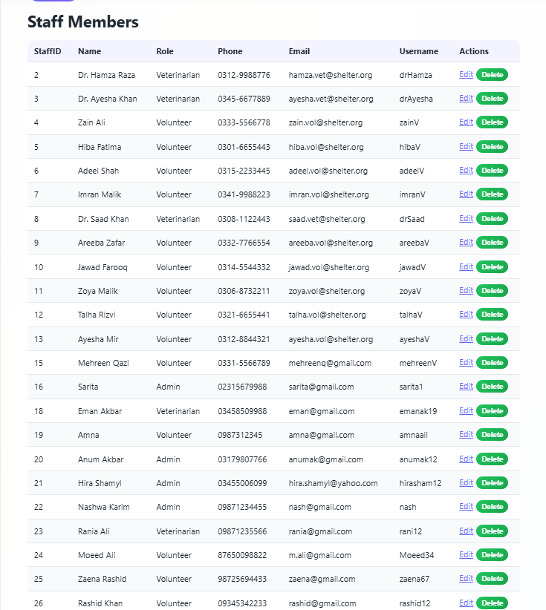
Hassan Raza Successfully deleted

Section:4 Challenges & Future Enhancements
During the development of Deliverable 3, the system encountered a handful of technical and design complications that required extra attention, even though they looked simple at first glance. One of the more persistent challenges involved handling relational constraints in the database. Certain records, such as appointments, treatments, and adoptions, depend very heavily on foreign keys, and the system became quite unhappy whenever an edit or delete attempt tried to disturb these relationships. This resulted in a series of unintended database protests that had to be resolved by keeping specific fields permanently read-only and by displaying clearer user messages whenever the database refused to comply.
Another difficulty appeared when dealing with datetime values, because HTML inputs, Node.js objects, and MySQL datatypes all insisted on using slightly different formats. The conversion step often behaved in unpredictable ways, which forced the system to adopt a stricter approach to formatting before any updates were sent to the database. Validation errors also created awkward situations where incomplete or incorrectly formatted data kept reappearing on the screen, so additional error handling mechanisms were added to prevent the forms from collapsing under their own confusion.
On the interface side, the transition from plain, unstyled HTML to a unified visual layout required reworking nearly every page. It was surprisingly easy for small inconsistencies to slip through, causing certain buttons or sections to appear out of place. The introduction of a shared wrapper and styling conventions eventually fixed this, but the adjustment period was long enough to feel slightly chaotic.
Looking ahead, there are several improvements that would make the system far more practical for real shelter operations. A future version could include user authentication, role-based access control, and a proper login system so that volunteers, veterinarians, and administrators do not all have identical privileges. More advanced search and filtering features would also help staff navigate large datasets, especially when the system accumulates many animals, adopters, or historical treatment entries. Automatic reminders for appointments or low room availability could also make the system feel more intelligent instead of simply reactive. Finally, converting the interface into a fully responsive layout would allow staff to use the system comfortably on tablets or mobile devices while working around animals, which is where they often end up standing anyway.
Overall, although Deliverable 3 introduced some stubborn obstacles, the changes made the system noticeably closer to something that resembles an actual animal hospital and shelter management tool, even if the journey to get there occasionally felt more confusing than expected.

